Creating Class Diagrams

Creating Class Diagrams in Enterprise Architect 1
What is a class diagram? 1
Creating the Diagram 3
Creating Associations 8
Specifying the Role 9
Multiplicity 10
Aggregation and Composition 12
Composition 12
Aggregation 12
Creating Attributes 14
Creating Operations 16
Re-Factor 18
Thinking about Collections 18

Creating Class Diagrams in Enterprise Architect
Having seen how we create our use case diagrams we will now have a go at creating a class diagram.

What is a class diagram?
In creating our system we will at some point need to create some code.
This code will inevitably be organised into classes that will in turn be stored in a class library.
Before we get to the stage of thinking about the code we need to spend some time thinking about the problem at hand.
Class diagrams allow us to step back from the problem and think about what the classes are going to do.
For example here is a class diagram for an address book…

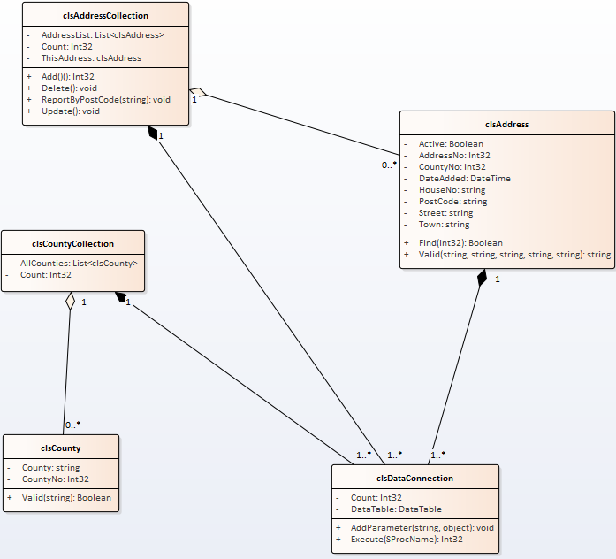
Each class is defined as a rectangle linked by different types of associations.
Within the rectangles we specify the class name along with attributes (properties) and operations (methods).
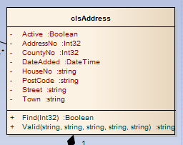
Operations (Methods)
Name
Attributes (Properties)
The class diagram is ultimately implemented as code in our system…
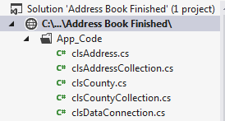
Containing the code that implements the attributes and operations as methods and properties…
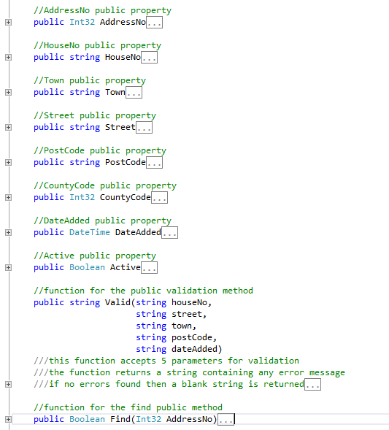

Creating the Diagram
Right click on Structural View (Middle Layer) and add a new diagram...
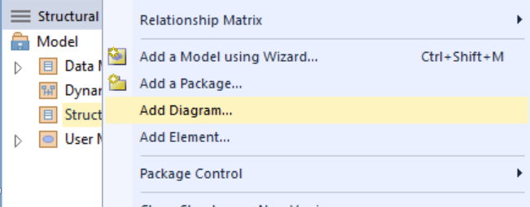

In this case we want UML Structural and Class...
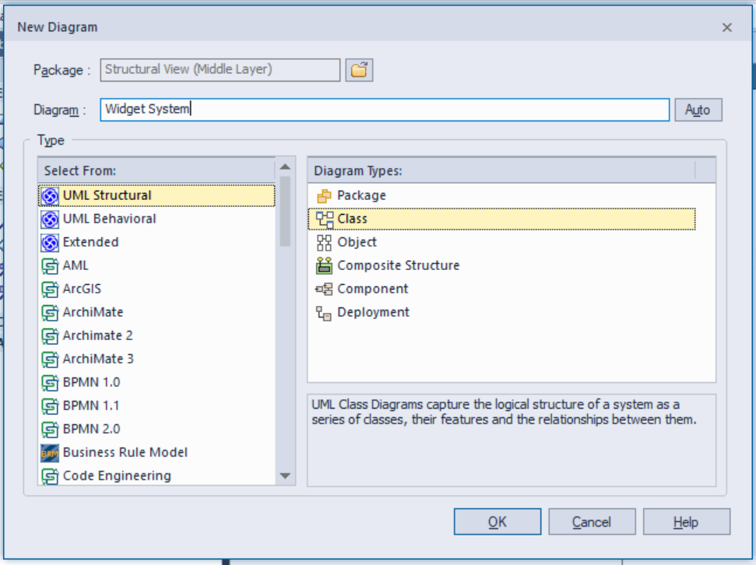
Don’t forget to give the diagram a sensible name and then press OK.
You should see the diagram created for you...
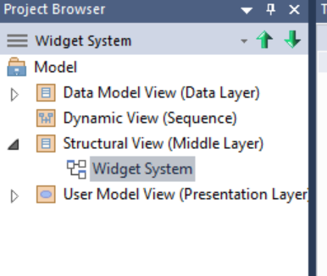
Double click the diagram to edit it.
In order to create the initial class diagram we need to revisit the specification to identify candidate classes. I say candidate as we may not be right in our first go and like all documents there will be revisions made to them as the picture of how the system works comes together.
The first thing we will look at is the detailed specification.
A customer visits the web site to buy some widgets. They have the option to add themselves as a customer to the system and edit their details. Also they are able to cancel their account on-line. Upon finding out that they are not a customer they follow the sign up process entering their details and selecting a user name and password.
On the back end of the system staff have the option to manage the data for all customers (add, edit delete) and run reports on customers.
One way to approach this is to sit down as a team and identify the nouns in the specification. The nouns give us an indication of the things (objects) that need to be handled by the system.
So as a first stab...

A customer visits the web site to buy some widgets. They have the option to add themselves as a customer to the system and edit their details. Also they are able to cancel their account on-line. Upon finding out that they are not a customer they follow the sign up process entering their details and selecting a user name and password.
On the back end of the system staff have the option to manage the data for all customers (add, edit delete) and run reports on customers.
This gives us the following initial list...
- Customer
- Widgets
- Web site
- Account
- System
- Details (?)
- Customers
- Reports
We now need to filter the list to decide if these really are classes. This takes some thought and skill however we face similar problems for when we were thinking about use cases.
- Web Site?
Is the desk really part of our computer system? Probably not!
- What about System?
We don't include the system on the class diagram as the diagram represents the system. (Unlike when the system is an actor in a use case!)
Have we identified the same class by different names?
- Account and details? Possibly!
Do hedge your bets a little bit though you may find later that you need to change your mind.
So let's filter the list like so and see how we get on...
- Customer
- Widgets
- Account
- System
- Customers
Let’s have a go at creating a class definition for Widget (singular).
To create a class on the diagram select class in the toolbox and draw it onto the diagram...
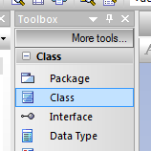
Give the class the name clsWidget...
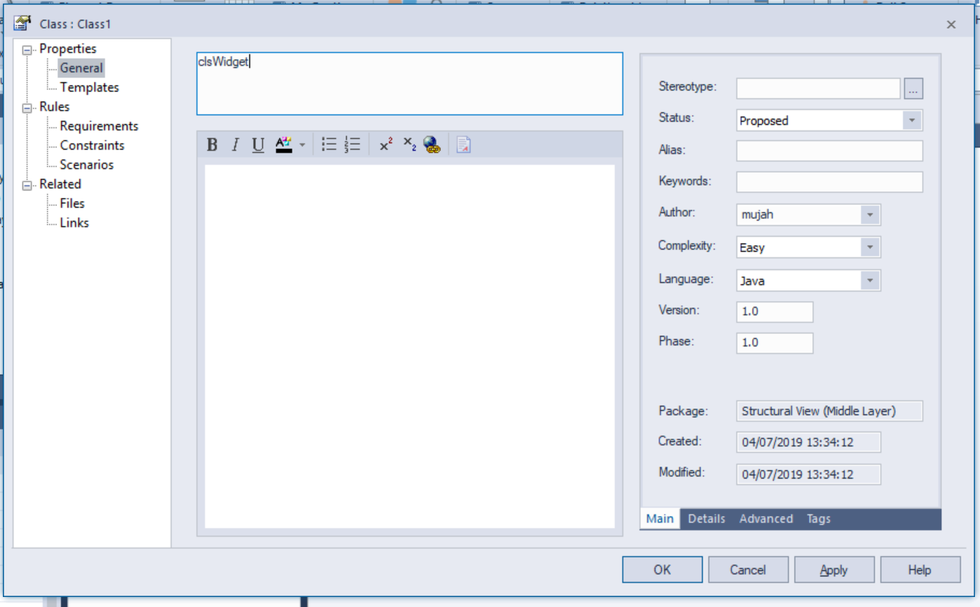
Change the language for the class from Java to C# so that it supports the data types for the language we want to use.
You should then see the class on the diagram...
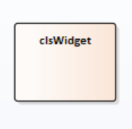

Creating Associations
An association describes how and if two classes are going to interact with each other in some way.
The first step in identifying associations is to take another look at the event table.
Subject | Verb | Object | Response
Staff | Adds | Widget | Data accepted by the system
System | Validates | Widget | Reports errors if there are any
System | Edits | Widget | Old data updated with now

From the event table we can see a clear link between the Staff and the Widget.
Create the second class like so...
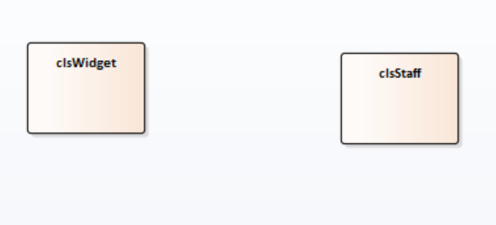
To create the association in EA we again, draw the link between the two classes.
From the toolbox select the associate tool…
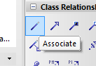
And then draw the association between the two classes.
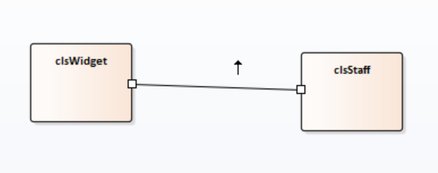

Specifying the Role
The next step is to specify the role between the classes. This describes what is going on.
Double click on the association to access the properties for the association.
For clsWidget the role is “Input By” and for clsStaff the role is “Adds”…
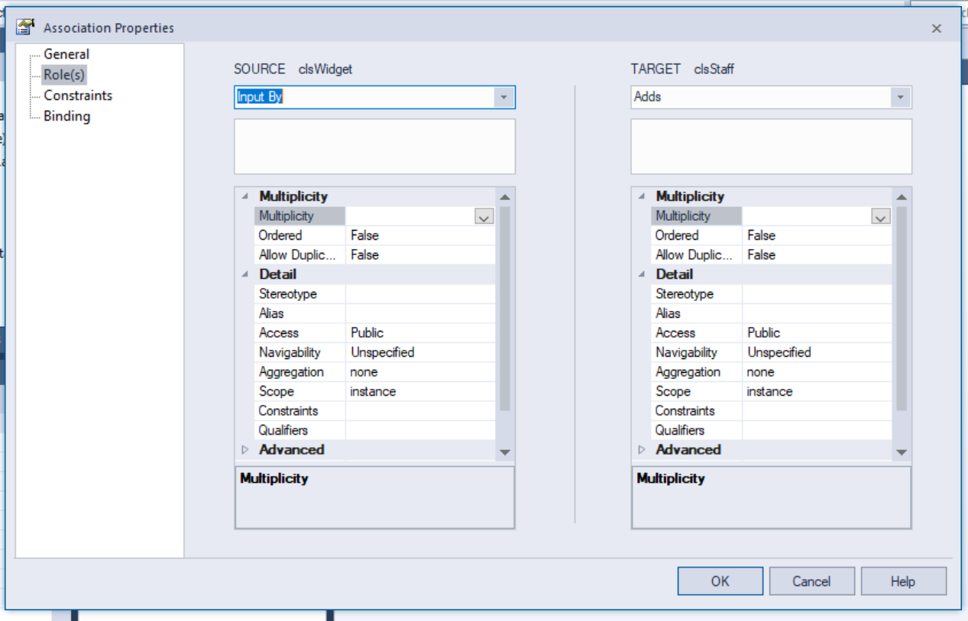
Set the Target role as “Input by” such that the diagram looks like this…
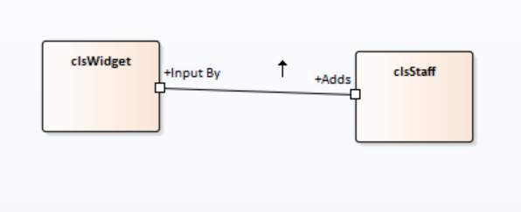

Multiplicity
The multiplicity describes how many of a certain class are associated to another.
This is where it pays to apply a bit of thought.
(There may be room for debate depending on how you understand the business rules!)
To set this up in EA double click the association to set the multiplicity…
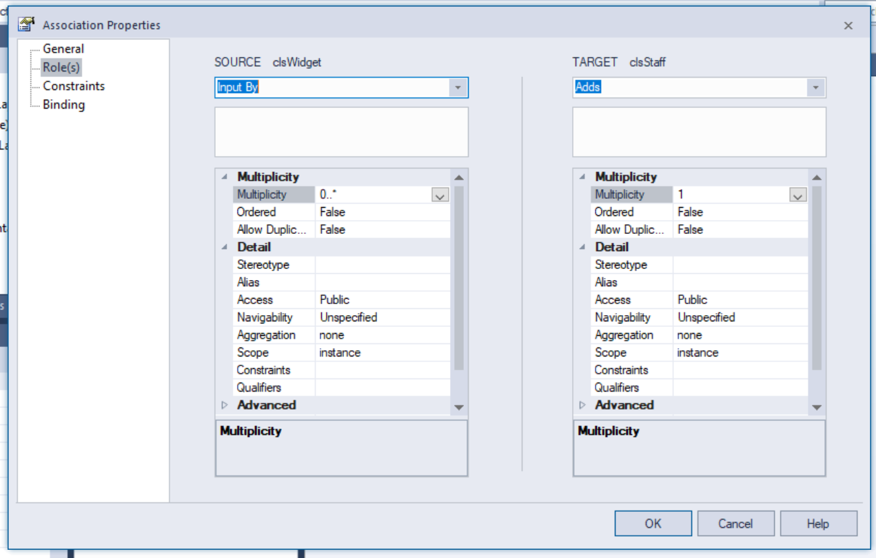
Do the same for each end such that it looks like this…
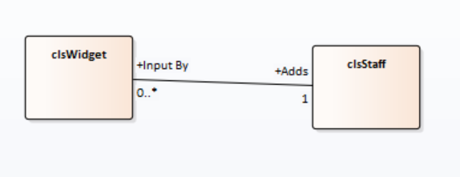
The symbols indicate…
1 only one
1..* one or many
0..* zero or many

Aggregation and Composition
Aggregation and composition are useful perspectives on the association that help us to think more clearly about the design. Aggregation and composition will ultimately influence how we write our code.

Composition
Two classes are related via composition when you cannot have an instance of one class without the other class.
For example if we were placing an order in a system could we ever have an order line without an associated order?
Order
Order Line
Has
1
0..*
Attributes
Operations
Attributes
Operations

The answer is “no”.
To indicate this strong relationship between the two classes we use a solid diamond like so…
Order
Order Line
Has
1
0..*
Attributes
Operations
Attributes
Operations

Aggregation
The other association type between classes is an aggregation.
In this case we are asking the question “can this class exist without the associated class even though they have a relationship?”
A good example of this is customer and address…
Customer
Address
Has
1
1..*
Attributes
Operations
Attributes
Operations
If all of the customers were to vanish from our store would addresses cease to exist?
Obviously the answer is they would not!
To indicate this looser relationship a white triangle is used like so…
Customer
Address
Has
1
1..*
Attributes
Operations
Attributes
Operations
So in the case of Widgets and Staff classes we need to ask the question.
Can one exist without the other?
Would we ever want to use code for handling staff independently of widgets?
Would we ever want to manipulate widgets without worrying about who entered them?
The answer to both of these questions is probably “yes”.
In which case the association is an aggregation.
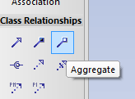
Use the aggregation tool to aggregate the two classes such that it looks like this…
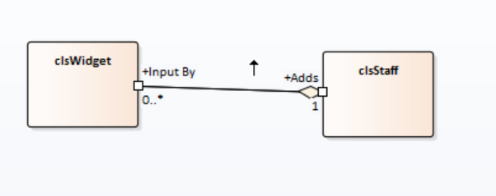
Does it work both ways?
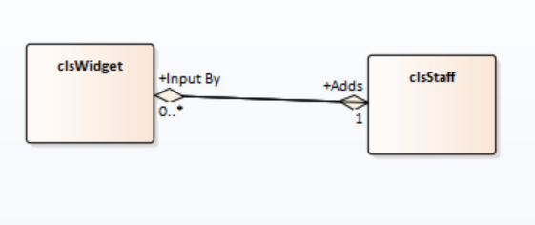

Creating Attributes
Having created the candidate classes we may now add some attributes.
For this example we shall look at the Widget class.
Two obvious attribute for this class are WidgetID and Description.
To add attributes, right click on the class and select features and properties, then attributes…
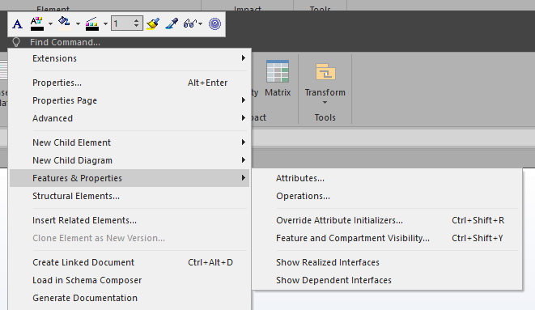
Set up the attribute WidgetID like so…
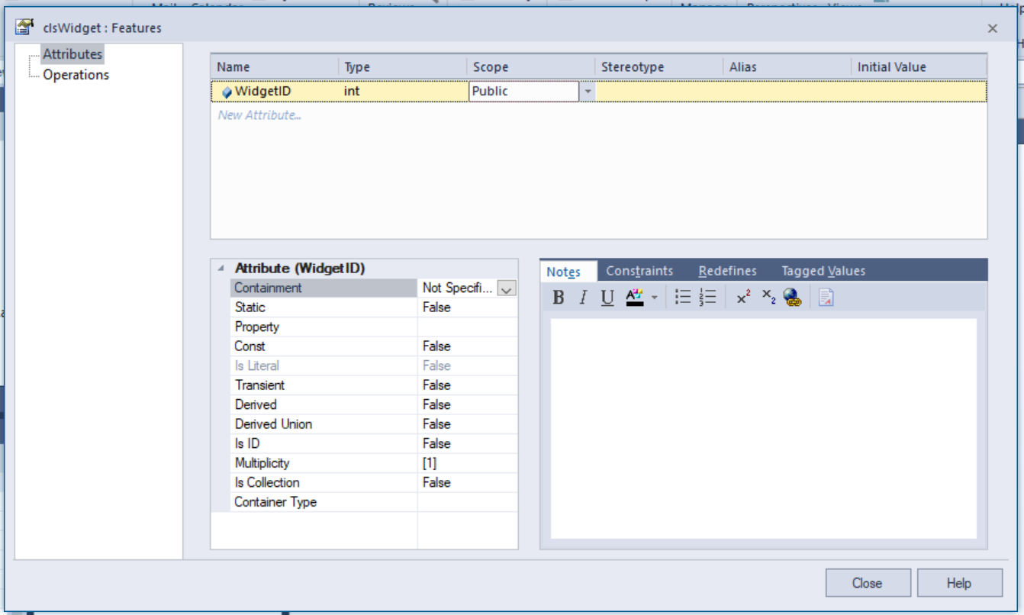
Press Close and you will see the attribute in the class…
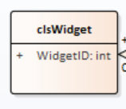
Do the same for the Description attribute like so...
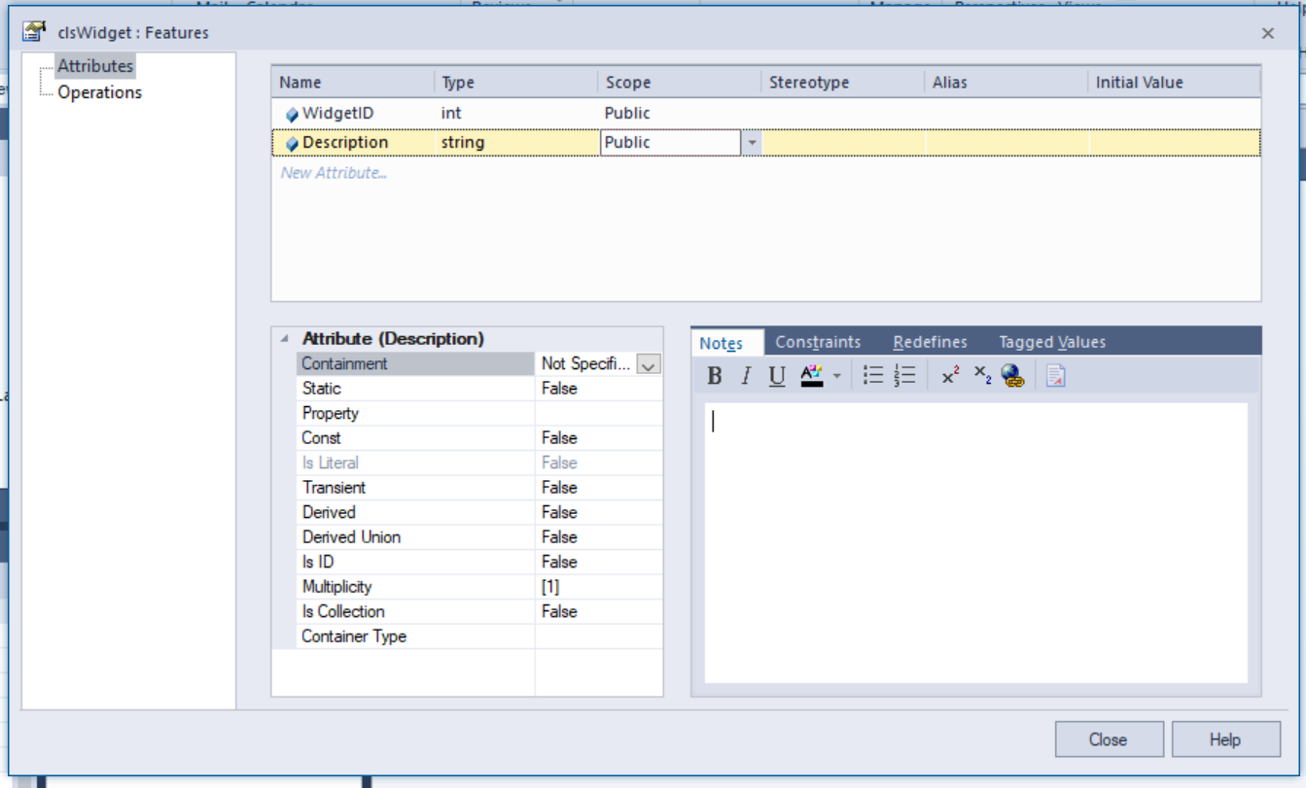

Creating Operations
Operations will ultimately become our methods when we write the code.
We need to think about a candidate operation for this class. How about Find?
Find(Int32 UserNo) Boolean
As with attributes we right click the class to add the operation…
Set up the operation like so…
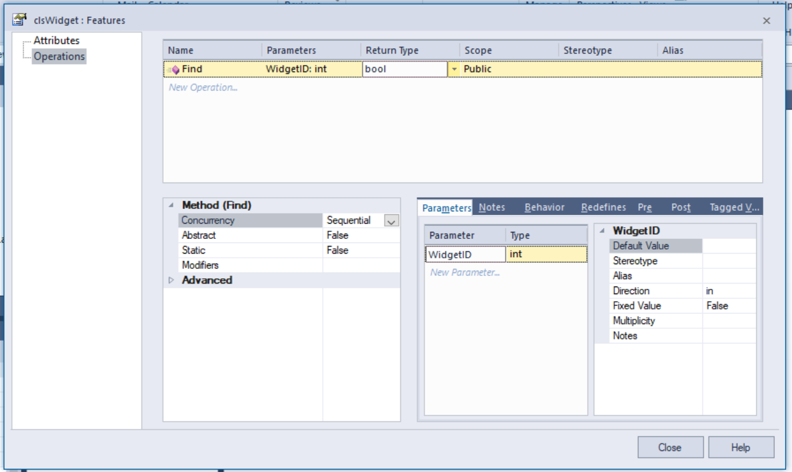
The class should now look like this…
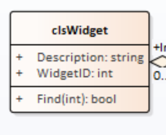
In this case we are saying that the Find operation will accept a single parameter of type integer containing the value of the WidgetID to find. The operation returns true if the record is found, false if not.

Re-Factor
What does that mean?
It means that at every stage of the project we need to stop and think about two things.
- Is what we have done actually correct?
- Is there a better way of doing the same thing?

Thinking about Collections
Is the relationship between staff and widget or staff and the widget collection?
When first creating class diagrams it is very easy to think of them as being the same as entities.
In our current diagram does it actually make sense?
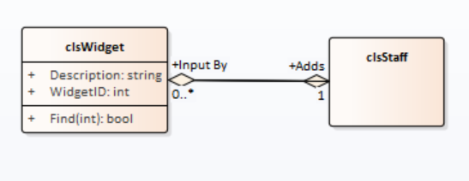
Yes, a member of staff adds a widget but is that where the Add functionality needs to go?
Add is a list related operation so it makes sense to place the operation in the collection not the item.
Take a look at this modified diagram...
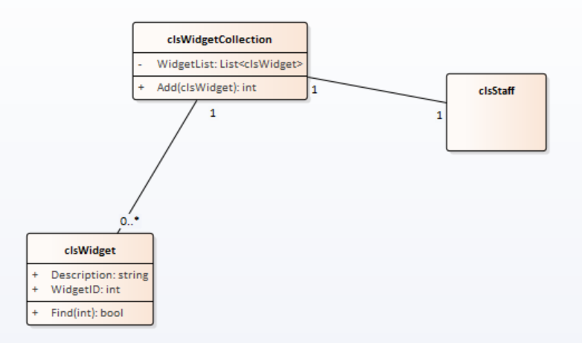
In this revised design a member of staff uses one widget collection to add widgets.
Note that unlike in an ERD we can have 1:1 relationships. The same is true for M:M!
How we relate the classes and the role of collection classes requires some thought.

Checklist
Have you included the data connection class? If so, remove it!
Do you have both item classes and collection classes?
Have you set up your associations?
Is multiplicity included?
Have you identified your compositions and aggregations?
Do your classes cover the basics? Add, edit, delete etc.

